Project “Grail”

- Main idea
  - Abstract
  - Aims
  - Principles
  - Motivation strategy
  - Check system
  - Measures
- DB
  - User
    - Profile
    - Stats
    - Friends
    - Activities
  - Achievements
  - Skills
  - Squire
- Apps
  - Interface
  - Model
- Monetization
  - List of possibilities

Main idea:

Abstract:

Many people all around the world spend a lot of their time, sitting in social networks/online games and loosing their time and energy.
It’s in human nature, to be social and having joy by playing. There is big area in psychology named gamification, about using game techniques in education, marketing and business. The same principles are used by game developers to make money, ruining millions of lifes. It’s dependence, worse then drug-dependence. It’s a little bit sad that humans use good technologies for corruption, not for growing.
But can we use this technology the different way, for rising? Or, in other words, can we use game for growing in our life? There are many local projects, education courses, some rules in marketing, that use this idea and almost all of them are successful. But them all has own little specialization and there are no one big system, that can unite all of them.
In this project, we wanna give a chance for any human to rise by playing. You can say, that any man, who want to develop can do this himself. Yes, but we can help him with motivation. Many people don’t believe in themselves, other just don’t know what to do. It’s hard to change yourself, but it’s much easier in game and together with friends.
Yes, as you may already guess, it should be a little social network with a great charge of motivation and comfy interface for drafting, realization and fixing achievements in real life.
A little Grail crusade for every man in the world. Cause getting Grail isn’t the main aim in the life. Main is to move to it and to rise on the way. We’ll show this way.

System aims:

- Make platform for personal development
- Create platform for uniting all other higher specialized platforms
- Get a lot of data for researching of development of man and motivation.

We’re waiting from users:
- registration
- working with us about few minutes a day, but every day
- post goals and achievements to social networks
- help us to upgrade system by ideas
- be a part of friendly development atmosphere

Principles:

- Gamification:
All process will be build using scenario and game shell for motivation

- Socialization:
It’s nature way to give some motivation, many features are bonded with social actions, competitions

- Free to play:
We’ll never take money from users, way to Grail should be the same for all men and money shouldn’t make obstacles on this way. The ways of monetization we shall show later.

- Crowdfinding:
Frankly, problem we’re trying to solve is huge and there are lot of areas it can be expanded. So we shall try to make the system, that will (in perfect case) develop itself. Of course, under our control. The other profit from this way – it’s part of gamification, when user see that he/she can change the network.

- Minimize a contact with user:
We do this system for rising of humanity, not for rising of visiting of our system. So we shall automate it as much as possible and make the simplest interface.

- Uniting of other education/development resources:
Our system may be a nice platform for uniting different other resources, later we’ll show how we’re going to do this.

Motivation strategy

- Atmosphere (dynamics)
  - Motivation texts, stories
  - Code of honor
  - Way to Grail
- Global public aims
- Global scenario, rising together with little crusader
  - Campaign
  - Behavior of crusader
- Competitions
  - Duels
  - Global challenges
- Game part
  - Experience
  - Stats
  - Coins
- Achievements
- Statistic

Inner motivation:
Competence
Autonomy
Relationships

Outer motivation:
Coins
Socialization
Scenario (interest)
Etc.

Check system

Of course, we understand, that it’s technically impossible to check data, that users will send to us. One of our main aims is to make atmosphere of honesty. It should be made by:
- Code of Honor (agreement between us and user on registration, when user promises to show his own and truly results)
- Users should understand, that they’re main bonuses are in life, and their results in game are just mirrors
- A little bit of control by socialization of a process

Simultaneously, there are many areas, where we can make perfect control:
- achievements, bonded with courses of partners
- some activities in sport
- some testable areas

But the most of activities is partly-checkable. For example:
- global aims – they are public, so we have mental control from friends of user
- duels – friends control each other
- daily quests
- skills might be partly-checked by other users with same skill
- etc

Our game shell shouldn’t instigate to pastiche, but justly reward for success. Mathematically, together with assessment of activities it’s the hardest part of project.

We’ll come back to this question in next chapters.

Measures

- Experience – classic point system. Shows time, spent by user in service. Progress in scenario bonded with this measure. User can get it by doing any activities.
- Stats – specialized experience. Shows time, spent by user in some specialized area. For example Intellingence, Strength, Goodness, etc. Unlock some micro-features.
- Coins – in-game money, that can be used for unlocking some mini-features. One of outer motivation methods.

Structure of DB

User

Profile
User ID – technical
Login – bijective image of ID, used by user for logging in system
Name – name, selected by user and displayed in-game
Age – age of user, used for search, legal questions, statistics and some micro-features
Sex – gender of user, used for search, statistics and some micro-features
Region – region of living, used for search, statistics and some micro-features
Gifts – just gifts from other users

Stats
Experience – it was defined before. User gets it by doing any activities. Used for counting level
Level – derivative from experience. Shows progress in scenario. New levels unlock next part of scenario story and some else micro-features.

Wisdom – shows time, used for development of intellect side. Allows micro-features
Strength – shows time, used for development of physical side. Allows micro-features
Art mastery – shows time, used for development of creativity. Allows micro-features
Willpower – shows real progress. Allows micro-features
Coaching – shows how user helped other users to rise. Allows micro-features
Nobility – social activity of user / help in upgrading system. Allows micro-features
Kindness – shows kindness ☺ Allows micro-features

Of course, all stats might be used for statistics.

Friends
Any two users can become friends
Should be search of friends
Groups of friends
Chat

Activities
Global aims – public big targets. Setting and accomplishment are posted and awarded in-game.
Targets – some local targets
- daily
- one-time
- habits
- skill trainings
Competitions – multi-player targets (only between friends)
- duels
- team competitions
- events

Achievements
Achievements – classical badges:
- In-game achievements
- Social achievements
- Partner achievements
- Unique achievements

Skills

List of competences of user. Can have different levels. Used for search, communication.
There are skill trainings by users with higher skill level and recommendations. Doesn’t give any preferences in-game.

Squire
All activities and achievements in-game are mirrored by mate – little squire, who started his way to grail and become a knight together with progress of user.
He’s main hero of scenario.
Also he’s assistant of user.
Can be personalized with appearance, different looks, items, temper etc.

Apps

Interface
Of course designers will do this much better ☺
It’s just some very global vision

Main screen
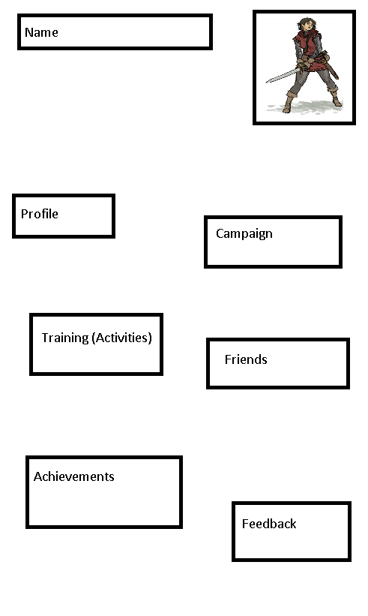

Profile screen
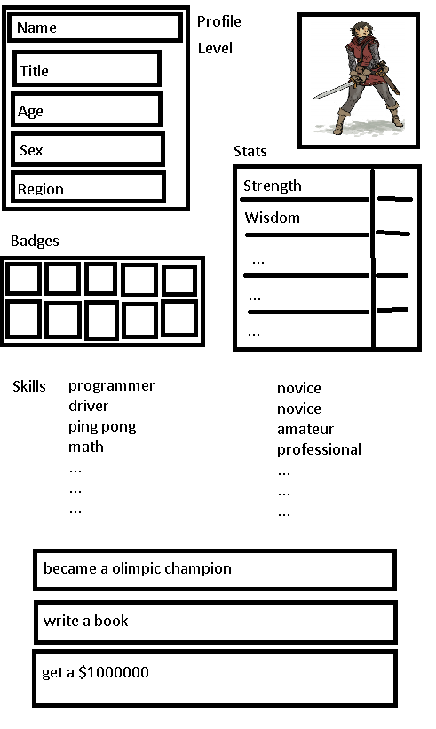

Training screen:
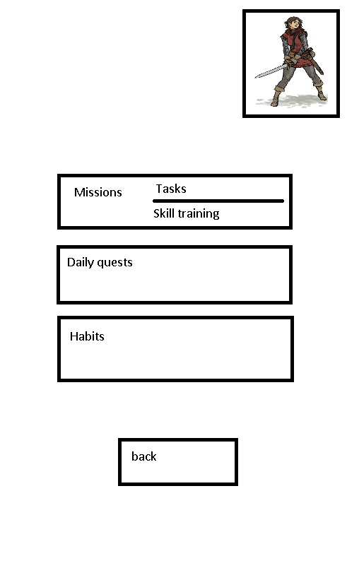
…

Model

What should we understand before creating a math model?
- We can’t check majority of information from users. That’s why we should valuate their progress, but not their level of skill/stat.
- We can’t compare different users. The reason is same. + The same activity for different people can be really different stride. We can’t valuate each user, but we can try to valuate progress of each user and make it clear to create motivation
- System of valuation should motivate user
- System of valuation should be dynamic (corollary from previous claim)
- System of valuation might be useful for statistics
- System should NOT catch in users

What should we valuate?
- we should valuate:
  - activities (in exp, stat points and coins)
  - achievements (in coins)
  - influence of stats on game-play
  - influence of experience on game-play
  - cost of features
- we shouldn’t valuate
  - skills
  - activities

So let us try to make some touches to strategy of valuation

First, we need a list of all measures that needed value:
- activities
  - intellect (+wisdom, exp)
  - physical (+strength, exp)
  - creative (+Art mastery, exp)
  - kind (+ kindness)
  - willpower generated by stable work
  - coaching – generated by training work of students
  - nobility – generated by social activities
- achievements
  - In-game achievements
  - Social achievements
  - Partner achievements
  - Unique achievements
- Influence of stats
  - Wisdom (in-game features)
  - Physical (in-game features)
  - Creative (in-game features)
  - Kindness (some gratitude features)
  - Willpower (unlock more habits and daily quests)
  - Coaching (some gratitude features)
  - Nobility (some gratitude features)
- Influence of experience
  - Moving through scenario
  - Some in-game features
- Cost of features
  - Coin strategy is special history

For example, let us model the experience numbers:
Suppose we have 42 levels. Why 42? You can ask global brain ☺
How long should user stay with us? Let it be, for example, about a year and half.
Should he end the scenario? Let we allow him.
Should our levels be of different difficult? I should remind you that our level is progress in scenario. Every level, or, if you want, part of scenario – is some lesson, some adventure. It can have different difficult. But, anyway, levels should be approximately the same. So let us divide 42 into 540. we’ll get about 0.07 lvl/day, or about 2 weeks for lesson/level/cycle/stage, as you like. So if for getting level we need about 1000 exp, we should get about 80 exp/day. It can be, for example 30 exp for daily tasks, 20 exp for working on habits, 20 for free tasks/duels and 0-20 random exp for other activities.
It’s good system for robot, but should it motivate a human. 2 weeks is too boring for getting some progress. What can we do? Nature way is to diversify process with some random events, local stages, communication and surprises. But anyway, it’s not bad if we have good lessons and interesting atmosphere. I should remind you, that we’re trying to minimize a contact of man with system and real progress should be in real life. From this point of view our system is good if we’ll make successful system.

Now let us go down to the lower level of system. 30 exp points for daily tasks. Let us try to count difficult of task by time, used for completing it. For example, reading a book for 15 mins, doing morning exercises (5 min) and saying something nice to friends (let it be 10 mins). It’s clear that tasks are rly different, but I think 15, 5 and 10 exp points is ok.

Making habits needs consistency. So we can give 10 points for the first day, 11 for next, 12 for third and so on. To 15, for example. If somebody misses a day counting started from 10 again.

Etc.

It’s all just for explaining that in our system we can play with numbers as we like, in general all is ok. It’s much more important to make good atmosphere and design.

